

**School of Computer Science Engineering & Information Science**

**REPORT ON**

**FEEDBACK SYSTEM FOR ONLINE FOOD**

**Course Title: DATA ANALYSIS AND VISUALIZATION**

**Course Code: CSE2015**

**Date of Submission: 15/05/2024**

**Submitted By:**

|  |  |  |
| --- | --- | --- |
| **Sl.No** | **Roll Number** | **Name** |
| **1.** | **20211IST0003** | **Huzaifa Shariff** |
| **2.** | **20211IST0002** | **Sugunashree M K** |

**ENHANCING ONLINE FOOD SERVICE:**

**THE ANATOMY OF AN EFFECTIVE FEEDBACK SYSTEM**

**ABSTRACT:**

This abstract explores the significance of feedback systems in the context of online food services. It highlights how such systems facilitate the exchange of information between customers and businesses, contributing to enhanced customer satisfaction and continuous improvement. Features like ratings, reviews, surveys, and direct communication channels play crucial roles in gathering valuable insights, identifying areas for enhancement, and fostering trust and loyalty. By prioritizing customer feedback, online food services can refine their offerings, strengthen customer relationships, and achieve long-term success in a competitive market. The online food delivery service overcomes the disadvantages of the queuing system. This system sets up a food menu Ta feedback system in which customers can rate for food and also for delivery person. Customers can track their orders easily. The payment can be done through COD or online mode. In this study, an attempt has been made to analyze customer satisfaction with online food delivery services. 100 respondents were taken for the study. The data was collected from the respondents using a structured questionnaire. Various statistical tools were used to analyze the data collected and interpretations. his mainly designed primarily function for use in the food delivery industry. This system will allow hotels and restaurants to increase online food ordering such type of business. The customers can be selected food menu items just few minutes. In the modern food industries allows to quickly and easily delivery on customer place. Restaurant employees then use these orders through an easy to delivery on customer place easy find out navigate graphical interface for efficient processing.

**INTRODUCTION:**

An effective feedback system is the backbone of any online food service platform, serving as a vital bridge between customers and businesses. By providing a platform for customers to share their experiences, preferences, and concerns, these systems play a pivotal role in ensuring customer satisfaction and loyalty. Through features like ratings and reviews, customers can express their opinions on the quality of food, delivery speed, and overall service. These insights not only help other potential customers make informed decisions but also provide valuable feedback for businesses to identify areas for improvement.

Moreover, feedback systems often incorporate surveys to gather more detailed information about customer preferences and satisfaction levels. These surveys allow businesses to delve deeper into specific aspects of their service, such as menu variety, packaging quality, or customer service responsiveness. By analyzing survey responses, businesses can identify trends, patterns, and areas of strength or weakness, enabling them to make data-driven decisions to enhance their offerings.

Direct communication channels, such as customer support chat or email, further empower customers to provide feedback and address any issues they encounter in real-time. This personalized approach not only demonstrates a commitment to customer satisfaction but also allows businesses to resolve problems promptly, turning potentially negative experiences into positive ones. Additionally, actively engaging with customers through these channels fosters trust and loyalty, as customers feel valued and heard.

**IMPORTANCE OF FEEDBACK SYSTEM:**

A feedback system is crucial for online food services. It acts as a two-way street, benefiting both customers and restaurants. For customers, feedback helps them navigate the vast online food options by highlighting well-rated restaurants and dishes. It also allows them to voice concerns or compliments, ensuring a better dining experience next time. For restaurants, feedback provides valuable insights into customer preferences, enabling them to improve their offerings and address any shortcomings. In a competitive online food market, a strong feedback system builds trust and customer loyalty.

**KEY FEATURES OF AN EFFECTIVE FEEDBACK SYSTEM:**

An effective feedback system for online food needs to be convenient, informative, and actionable. Firstly, it should offer multiple channels for customers to leave feedback, like in-app surveys, pop-ups after delivery, or even social media integration. This ensures everyone has a chance to voice their opinion. Secondly, the system should be designed to gather specific details. Multiple choice options for aspects like food quality, delivery speed, and special requests can be paired with open-ended text boxes for more nuanced feedback. Finally, the platform should translate this data into actionable insights. Easy-to-understand reports for restaurants help them identify trends and areas for improvement, leading to a better overall online food experience.

**ARCHITECTURE MODEL:**

Data Collection Layer: This layer is responsible for collecting feedback from various sources, including customer reviews, ratings, surveys, and social media comments. It may also include data from order histories, user interactions, and demographic information. Data collection methods can include forms on the website or app, email surveys, social media monitoring tools, and APIs to integrate external sources.

Data Storage and Management Layer: Once feedback data is collected, it needs to be stored securely and efficiently. This layer includes databases or data warehouses where feedback data is stored. It may involve relational databases for structured data and NoSQL databases for unstructured data. Data management processes ensure data quality, consistency, and compliance with privacy regulations.

Data Processing and Analysis Layer: In this layer, feedback data is processed and analyzed to extract meaningful insights. This involves techniques such as data cleaning, normalization, feature engineering, sentiment analysis, and natural language processing (NLP). Advanced analytics and machine learning algorithms can be applied to identify patterns, trends, and correlations in the feedback data.

Visualization and Reporting Layer: The insights derived from feedback analysis are visualized and presented in a user-friendly format for stakeholders. This layer includes tools for creating dashboards, charts, graphs, and reports that communicate key metrics and findings. Visualization techniques such as heatmaps, word clouds, and trend analysis help stakeholders understand customer sentiment and behaviour.

Feedback Integration and Action Layer: Based on the insights generated from feedback analysis, actions are taken to improve the online food platform. This layer involves integrating feedback into decision-making processes, such as menu adjustments, service enhancements, marketing campaigns, and product development initiatives. Automated workflows and alerts may be implemented to trigger responses to specific feedback signals in real-time.

Feedback Loop and Continuous Improvement: The feedback system operates in a continuous loop of data collection, analysis, action, and evaluation. Feedback loops enable iterative improvements to the online food platform over time, ensuring it remains responsive to customer needs and preferences. Regular monitoring and measurement of feedback metrics enable stakeholders to track progress and adjust strategies accordingly.

By implementing this architecture model, online food platforms can effectively harness feedback data to enhance the customer experience, drive operational improvements, and achieve business success.

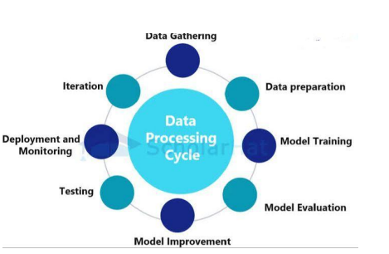

**EXPERIMENTAL SETUP:**

To set up an experiment for a feedback system for online food using a Kaggle dataset, you'll need to follow these steps:

1. Dataset Selection: Choose an appropriate Kaggle dataset that contains relevant information for your feedback system. Look for datasets that include data on customer orders, reviews, ratings, demographics, and any other factors you want to consider in your feedback analysis.
2. Data Preprocessing: Preprocess the dataset to clean and format the data. This may involve handling missing values, removing duplicates, standardizing data types, and performing any necessary feature engineering to extract meaningful insights.
3. Feedback System Design: Design the feedback system architecture, including how feedback will be collected from customers, stored, and analyzed. Determine the metrics and KPIs you'll use to measure customer satisfaction and the effectiveness of the feedback system.
4. Baseline Establishment: Before implementing any changes or interventions based on feedback, establish a baseline performance metric for the online food platform. This could include metrics like average order frequency, customer retention rate, or average rating.
5. Feedback Integration: Integrate mechanisms for collecting feedback into the online food platform. This could involve adding review forms, star ratings, or feedback surveys at various touchpoints in the customer journey.
6. Data Collection: Collect feedback data from customers using the implemented mechanisms. Ensure that the data is stored securely and can be easily analyzed.
7. Visualization and Analysis: Utilize visualization techniques such as heatmaps, charts, and graphs to analyze feedback data and identify patterns or trends. This step may involve using tools like Python libraries (e.g., matplotlib, seaborn) or business intelligence platforms.
8. Experimentation: Implement changes or improvements to the online food platform based on the insights gained from feedback analysis. This could involve menu adjustments, delivery process optimizations, or customer service enhancements.
9. Evaluation: Measure the impact of the implemented changes on key performance metrics. Compare the post-feedback system performance with the baseline established earlier to assess the effectiveness of the feedback system in improving customer satisfaction and business outcomes.
10. Iterative Improvement: Continuously iterate on the feedback system based on insights gained from ongoing data analysis and experimentation. Regularly monitor feedback metrics and make adjustments as necessary to ensure the online food platform remains responsive to customer needs and preferences.
11. Documentation and Reporting: Document the experimental setup, including the dataset used, preprocessing steps, feedback system design, experimental methodology, and results. Report findings and recommendations for future iterations or improvements to stakeholders or relevant parties.

**EVALUATION METRICS:**

Evaluation metrics are quantitative measures used to assess the performance of something. They essentially provide a score or value that helps us understand how well something is working.

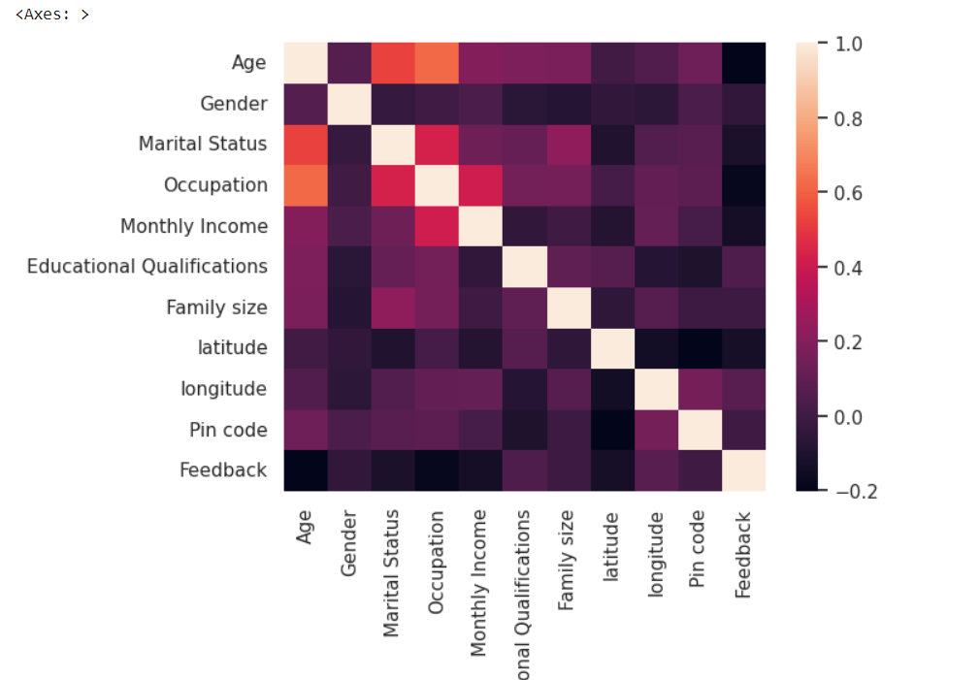

The resulting heatmap will be a colorful representation of the correlation coefficients. Each cell in the heatmap shows the correlation between two specific columns. Positive correlations (values closer to 1) are typically displayed in warm colors like red or yellow, while negative correlations (values closer to -1) are displayed in cool colors like blue. The intensity of the color reflects the strength of the correlation. This visualization helps you see at a glance which numeric columns in your data have strong relationships with each other.

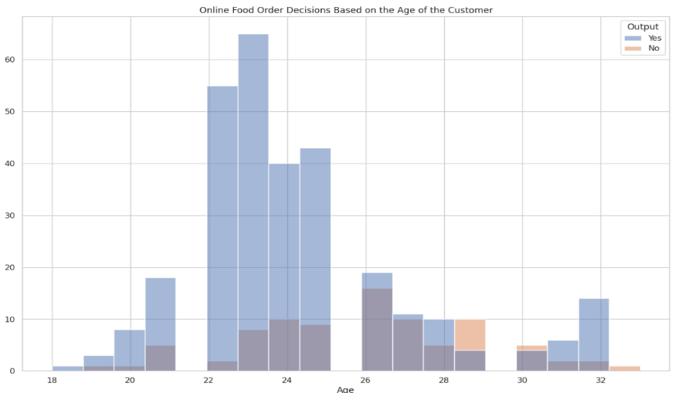

This code snippet creates a histogram where the x-axis represents the age of the customer and the y-axis represents the frequency. The colors in the histogram will be separated based on categories within the "Output" column, allowing you to visually analyze how online food order decisions might differ based on customer age.

**RESULTS :**



**PIE CHART**

This code segment creates a pie chart using the Plotly library to visualize the distribution of monthly income among customers who make repeat purchases on an online food platform. It starts by extracting the count of occurrences for each unique monthly income value from the "buying_again_data" DataFrame. Then, it prepares the labels and corresponding counts for the pie chart. Next, it defines the colors for the chart slices. After initializing the figure with the pie chart data, it updates the layout with a title. Additionally, it customizes hover information, text display, and marker properties. Finally, it displays the generated pie chart.



**HEAT MAP**

The code `sns.palplot(sns.color_palette("hls",8))` utilizes the seaborn library to display a color palette generated using the "hls" color space, containing 8 distinct colors. The `sns.color_palette()` function generates a color palette based on the specified color space and the number of desired colors. In this case, "hls" stands for hue, lightness, and saturation, which represents a cylindrical color space. The number 8 indicates the desired number of colors in the palette.

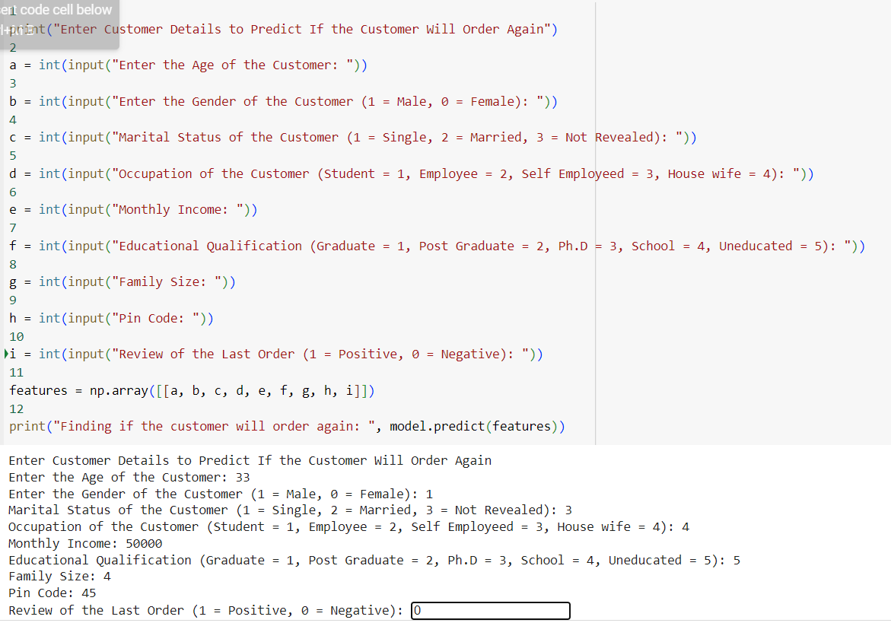

This Python script prompts users to input various details about a customer, such as age, gender, marital status, occupation, monthly income, educational qualification, family size, pin code, and the review of the last order. These inputs are stored in variables. Then, it constructs a numpy array containing these features. Finally, it utilizes a machine learning model (named 'model') to predict whether the customer will order again based on these features and prints the prediction result. This script essentially creates a user interface for predicting customer behavior using a trained model.

**CONCLUSION:**

In conclusion, the incorporation of a feedback system enhanced with visualization and heatmap datasets sourced from platforms like Kaggle offers profound advantages for online food services. By harnessing these datasets, food platforms can gain deeper insights into customer preferences, trends, and pain points, ultimately driving strategic decisions and operational improvements.

The utilization of visualizations such as graphs, charts, and heatmaps enables stakeholders to easily interpret complex data, identify patterns, and prioritize areas for enhancement. Heatmaps, specifically, provide a dynamic and intuitive representation of feedback data, highlighting areas of high activity or dissatisfaction, thus guiding targeted interventions and resource allocation.

Through the integration of these tools, online food platforms can foster a culture of continuous improvement, responding swiftly to customer feedback and market demands. This iterative approach not only enhances customer satisfaction and loyalty but also enables platforms to stay competitive in a rapidly evolving industry landscape.

In essence, leveraging visualization and heatmap datasets from sources like Kaggle empowers online food platforms to make data-driven decisions, optimize operations, and deliver exceptional culinary experiences that resonate with their customer base. This strategic use of data not only drives business success but also ensures the long-term sustainability and growth of the platform in a competitive marketplace.